**Lab 2 : Constraints in the E/R Model**

**We have the database consist of 5 relations:**

Product (ProductCode, Name, PurchasePrice, SellPrice, Type, SupplierCode)

Supplier (SupplierCode, SupplierName, Address)

Employee (EmloyeeID, FullName, Gender, BirthDate, Address)

Invoice (InvoiceID, SellDate, EmployeeID)

InvoiceLine(ProductCode, InvoiceID, Quantity)

**Exercise 1: Draw an ER model corresponding to the database above**

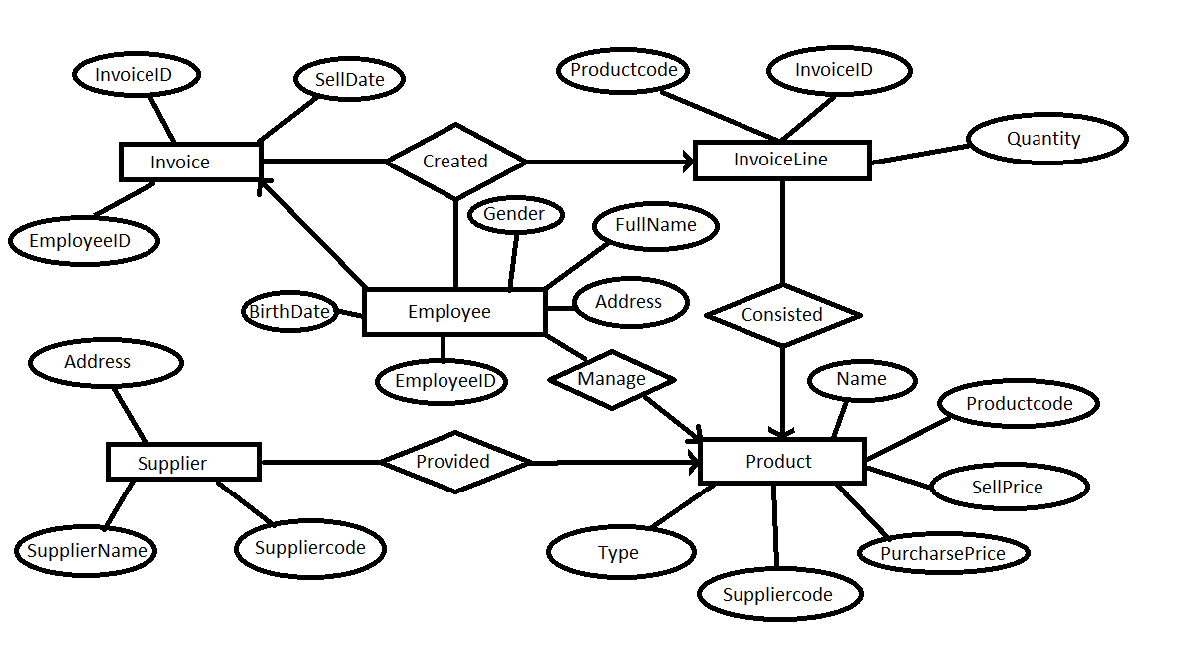

**Exercise 2: Use Relational Algebra to express following constraints:**

1. The sell price must be higher than the purchase price.

$σ$ SellPrice <= PurchasePrice(Product) = ∅

1. A product of Samsung must be television, mobile or tablet.

R1 = Product ⋈ Supplier

$σ$ SupplierName <> “Samsung” or ( Type <> “television” and Type <> “mobile” and Type <> “tablet”) (R1) = ∅

1. No supplier of mobile’s or tablet’s may also supply food.

Supplier(type!=mobile && type!=tablet) || supplier(type!=food) = ∅

1. No product may appear more than one time in an invoice.
2. The quantity of each product in each invoice should be greater than 0.

$σ$ Quantity <= 0 (InvoiceLine)

1. There is no invoice without product.
2. If purchase price is less than 500.000 VND, the sell price could not be greater than 9.000.000 VND.

$σ$ PurchasePrice >= 500000 and SellPrice > 9000000(Product) = ∅

1. The sell price could not be greater than 2 times the purchase price.

$σ$ SellPrice > 2 x purchasePrice (Product) = ∅

1. The gender of an employee should be “Male” or “Female”.

$σ$ Gender < > “Male” and Gender < > “Female” (Employee) = ∅

I1. The gender of an employee should be “Male” or “Female”, if gender is male so month is positive.

True: $σ$**(**Gender =“Female”) or (gender=“male” and birthdate.month.positive)(Employee)

False:(gender != ‘female’) and (gender =’male’ and birthdate.month.negative)

1. With the same purchase price, the sell price of two products could not have the difference more than 0.5 times of the purchase price.